Exercise 1-2

Configure your SharePoint Framework development environment

In this exercise, you'll set up your local developer environment with everything you need to start creating SharePoint Framework components.

## Step 1. Install a code editor

You'll need a text editor to edit your code files. There are no requirements for what you need in a text editor.

The remainder of this lab, and most of the examples you'll find from Microsoft, use [Visual Studio Code](https://code.visualstudio.com/).

## Step 2. Install Node.js

The tools used in compiling, debugging, and packaging SharePoint Framework projects are built using Node.js, which is a runtime that enables JavaScript to run locally versus in a browser. Therefore, the first step is to install the runtime, Node.js, before installing the required tools.

Node.js is available in two different releases: the long term support release (aka: LTS) is the most stable version that is recommended for most users while the current version contains the latest features. Before installing Node.js, you should verify that you haven't installed it previously. Open a command prompt or terminal (depending on your developer platform) and execute the following command:

node -v

If a version number is returned, you already have Node.js. The version(s) of Node.js you may use depends on the environment(s) you will be targeting.

If you are building projects for SharePoint 2016, then you should not use Node.js v10.x. If you do you will not be able to debug SharePoint 2016 projects in the local or SharePoint-hosted workbenches. It is recommended that you instead install Node.js v8.x, which means that the maximum version of the SharePoint Framework Yeoman generator you may use is v1.10.0.

If you are building projects for SharePoint 2019 and/or SharePoint Online, then it is recommended that you install Node.js v10.x and the latest version of the SharePoint Framework (which is currently v1.11.0).

### SharePoint Framework / Node.js Compatibility

| SharePoint Framework / Node.js Compatibility | |
| --- | --- |
| **SPFx** | **Node.js** |
| v1.11.0 | v10.x |
| v1.10.0 | v8.x, v10.x |
| v1.9.1 | v8.x, v10.x |
| v1.9.0 | v8.x, v10.x |
| v1.8.2 | v8.x, v10.x |
| v1.8.1 | v8.x |
| v1.8.0 | v8.x |
| v1.7.1 | v8.x |
| v1.7.0 | v8.x |
| v1.6.0 | v6.x, v8.x |
| v1.5.1 | v6.x, v8.x |
| v1.5.0 | v6.x, v8.x |
| v1.4.1 | v6.x, v8.x |
| v1.4.0 | v6.x, v8.x |
| v1.2.0 | v6.x, v8.x |
| v1.1.1 | v6.x, v8.x |
| v1.1.0 | v6.x |

For SharePoint Framework v1.1.1 through 1.4.0, a workaround is required when debugging in the local or hosted workbench if you have Node.js v8.x installed. Please see the following GitHub issue for more information: [Run gulp serve with 'NODE_NO_HTTP2=1' when using SPFx on node v8](https://github.com/SharePoint/sp-dev-docs/issues/1002).

If you already have a version of Node.js that's compatible with the environment(s) you'll be targeting, then skip to the next section, unless you want to switch to NVM to manage Node.js

### Option 1. Install Node Version Manager (NVM)

Normally, only one version of Node.js can be installed in your local environment. This becomes a challenge as SPFx continues to advance, using newer versions of Node.js, but your projects were built using an earlier version. Node Version Manager solves this by allowing you to install multiple versions of Node.js and switch as needed.

Install the latest version of NVM from the following sites, based on your OS:

* Windows: <https://github.com/coreybutler/nvm-windows/releases>
* MacOS/Linux: <https://github.com/nvm-sh/nvm>

Once install, open a command prompt and confirm nvm was properly install by entering

nvm version

Use the SharePoint Framework / Node.js Compatibility chart in the section above to determine the appropriate major version of Node.js. To see the minor versions of Node.js available to install, use the following command:

nvm list available

In the LTS column, choose the latest minor version for the major version you need. If you need a major version that is not in the list, you can find all versions available on the following page: <https://Nodejs.org/en/download/releases/> Choose the latest minor version for the major version you need.

Install Node.js with the following command:

nvm install 10.22 (where 10.22 is the version to install)

If you are using NVM for Windows, you must manually switch to use the new version with the following command:

nvm use 10.22

To see all version of Node.js installed locally, use the following command:

nvm list

### Option 2. Manually install Node.js

**NOTE: If you installed Node.js via NVM in the section above, skip to the next section.**

Open a browser and navigate to the Node.js Foundation site: <https://www.Nodejs.org>.

The LTS version is currently 12.x so you will need to navigate further into the site to find the appropriate installer.

Select **Downloads** from the top menu navigation then scroll to the bottom of the page and select **Previous Releases**.

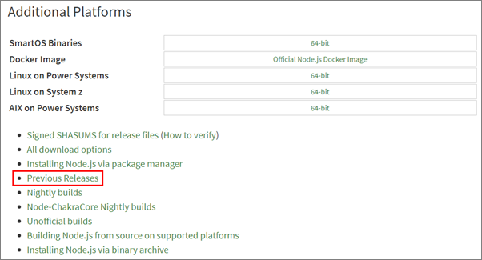

In the Previous Releases page, select Node.js 8.x if you'll be targeting SharePoint Server 2016 or Node.js 10.x if you'll be targeting SharePoint Server 2019 and/or SharePoint Online.

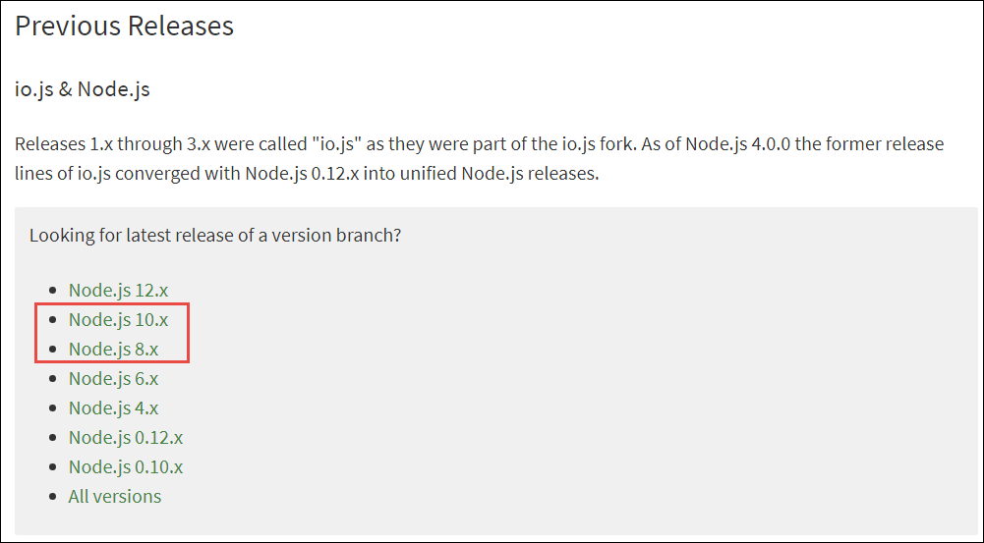

Download the appropriate installer or binary for the platform you're using.

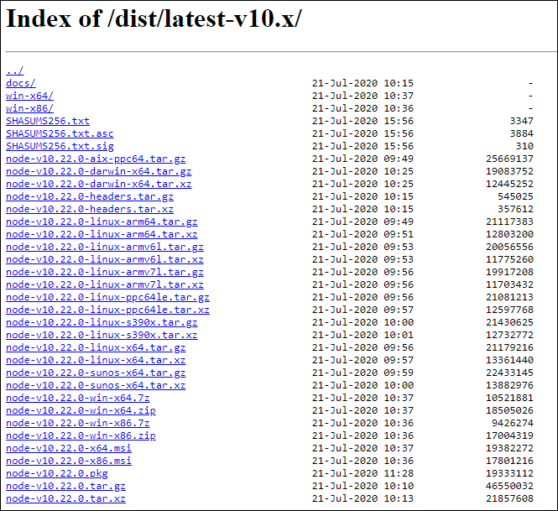

Run the installer, accepting all the default options. This will install Node.js and NPM (a package manager that Node.js uses, similar to .NET's NuGet).

## Step 3. Install required tools

The SharePoint Framework development experience uses a set of tools built on Node.js that are popular among web developers. These tools are built on Node.js, which means they can be used on any platform and will work the same way. This includes Windows, macOS, and Linux.

### Install Yeoman

Yeoman is a scaffolding engine, which executes generators that prompt the user with questions. Based on the answers to these questions, Yeoman then creates the folders and files defined by the generator.

Open a command prompt / terminal window and execute the following command to install Yeoman globally with NPM:

**npm install --global yo**

### Install the SharePoint Framework Yeoman generator

Microsoft has created a Yeoman generator for scaffolding SharePoint Framework projects.

To install the latest version of the SharePoint Framework Yeoman generator globally with NPM, open a command prompt / terminal window and execute the following command:

**npm install --global @microsoft/generator-sharepoint**

To install a specific version of the SharePoint Framework Yeoman generator globally with NPM, open a command prompt / terminal window and execute the following command:

**npm install --global @microsoft/generator-sharepoint@[version number]**

For example:

**npm install --global @microsoft/generator-sharepoint@1.9.1**

### Install Gulp

Gulp is a task runner utility. It's similar to MSBuild, a tool used by .NET developers and Visual Studio to compile projects, package solutions, and start a debugging experience.

Open a command prompt / terminal window and execute the following command to install Gulp globally with NPM:

**npm install --global gulp**

## Summary

In this exercise, you set up your local developer environment with everything you need to start creating SharePoint Framework components.